SOP For Weekly Wires – SPRIM, STRUX, STPEX
  - August 2026
Prepared by TresVista

Table of Contents
- Applications/Reference Files 4
- Purpose 4
- Procedure 4
- Automation Platform Options
- Conclusion 8

SOP Sign Off & Responsibility Matrix
Name | Date of Sign Off
Version 1.0
John Morin, Alex Husslein, Luke Saunders
Abhishek Agarwal
Akancha Kasera
Sandheep Baskar

Responsibility Matrix
StepStone Requestor | John Morin, Alex Husslein, Luke Saunders
TresVista responsible parties | Abhishek Agarwal, Akancha Kasera, Sandheep Baskar

Applications/Reference Files
- Fund Accounting Documents - StepStone Private Wealth - Fund Accounting Documents - All Documents
- Wire Template - StepStone Private Wealth - Weekly Inbound - All Documents
- SPI Reporting - Home | Reporting

Purpose
The objective of this project is to develop a template for US funds that includes wire instructions for capital calls scheduled for the upcoming week (Monday to Friday) from various investments of SPRIM, STPEX and STRUX funds. This will ensure the timely execution of capital call payments.

Procedure
- Roll forward the previous week’s file and delete the capital calls of the previous week (StepStone Private Wealth - Weekly Inbound - All Documents)
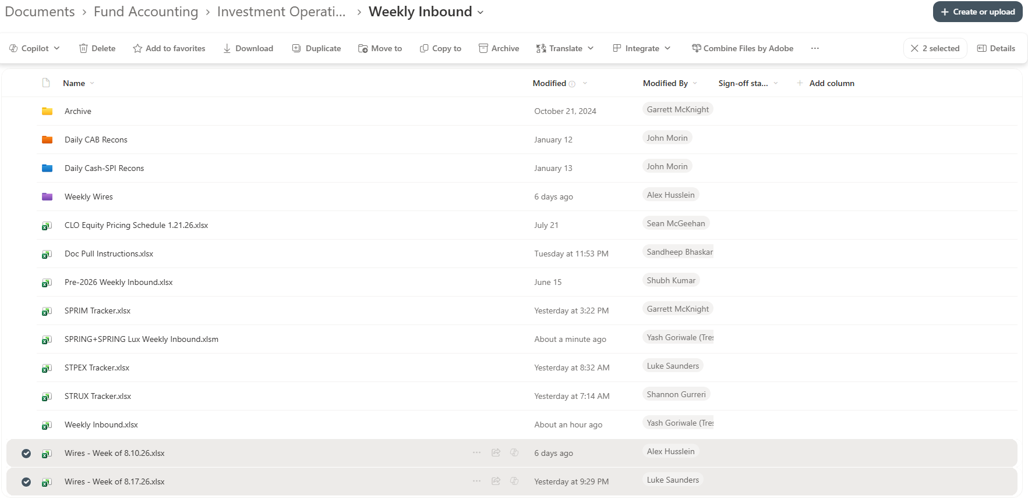
- Look out for the capital calls of the following week (Monday to Friday) in the cashflow folder of the respective fund and timeline
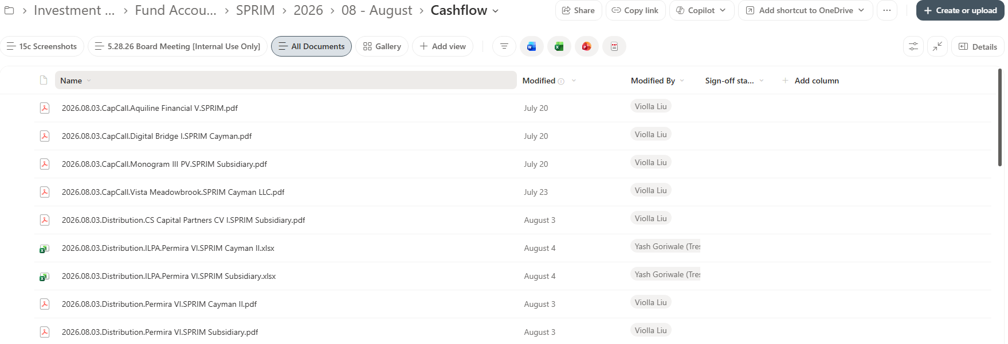
- Update the Fund, Date, Investment Name, Wire Amount, Currency, Account Name, and Link to Notice columns with the relevant details from the capital call notice, and attach a screenshot of the notice mentioning details like the account name, amount, and wire payment details/banking details:
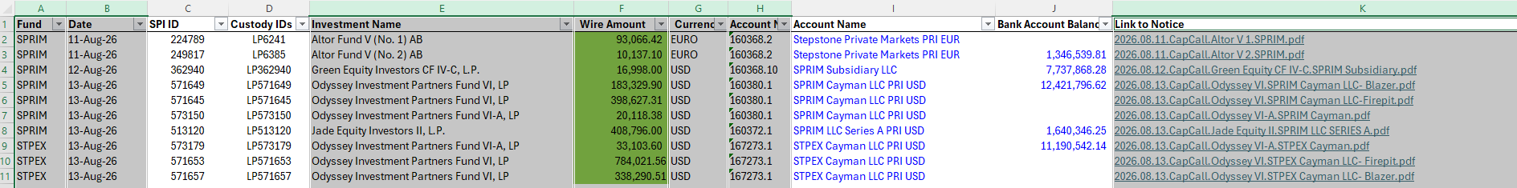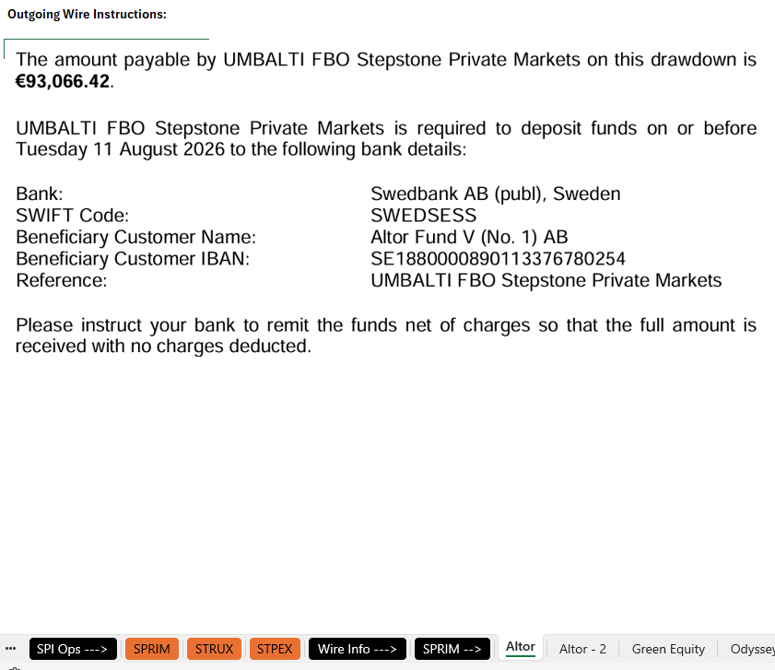

Alternatively, if the wire instructions are not available in the notice, it can be retrieved from SPI in the following way:
Log into SPI reporting and select to the Portfolio Profile of the fund:
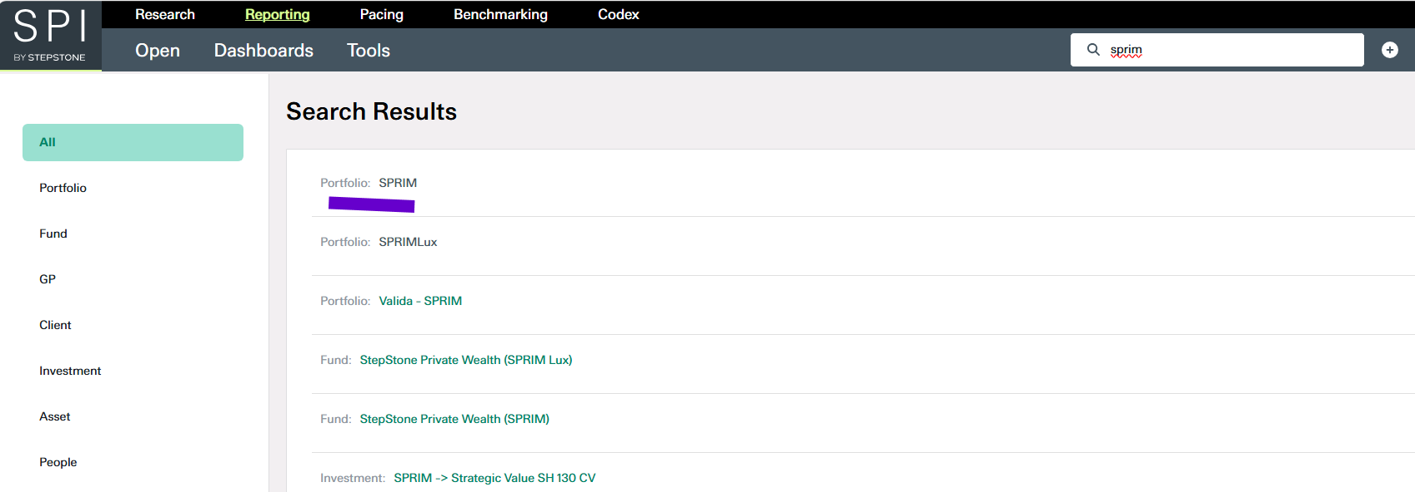
Navigate to the Operations tab and set the end date in the Date Range section as the due date mentioned in the notice:
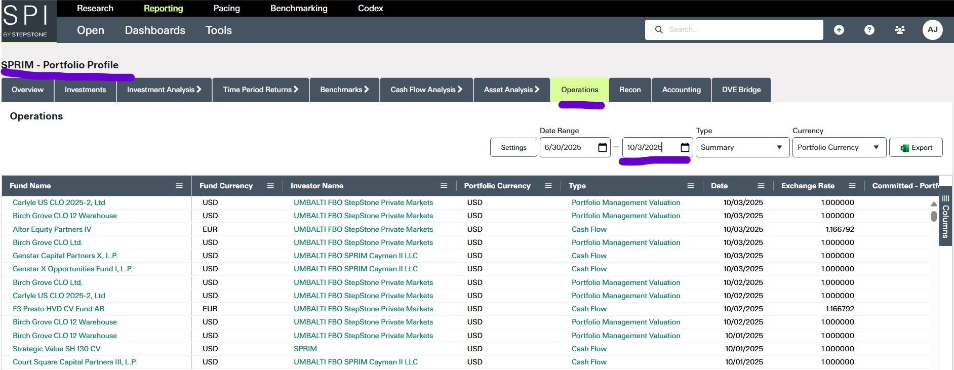
Lookup the investment name in the Fund Name column and click on the corresponding cell in the Type column:
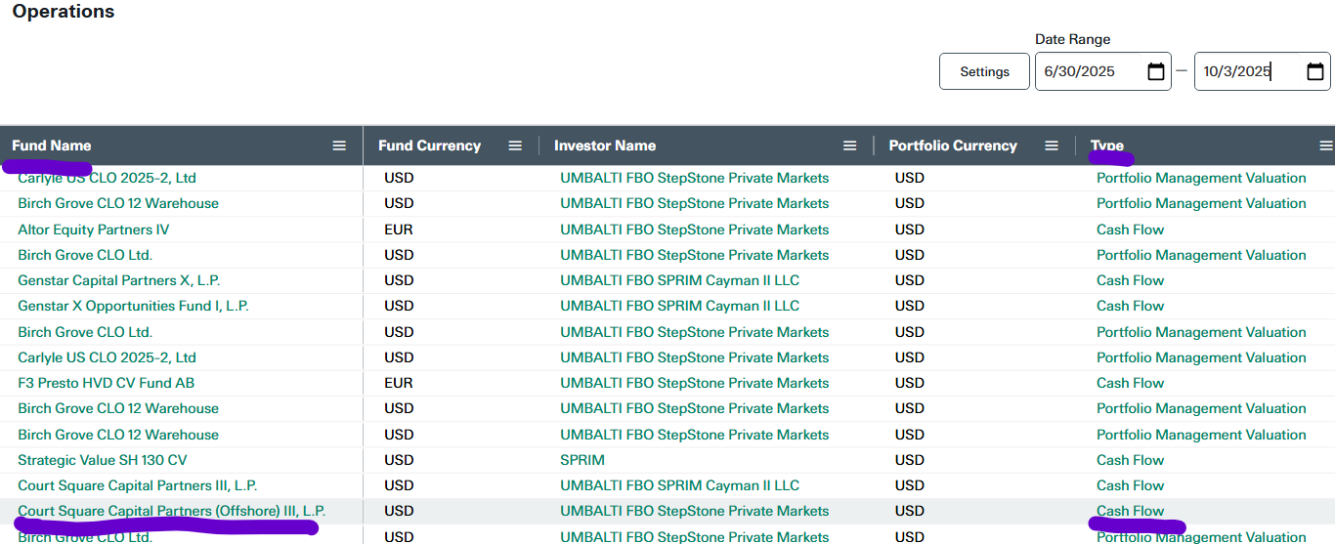
Click on the link mentioned in the Doc Location section, lookup the respective notice in the resulting SPAR portal and fetch the wire instructions from the notice.
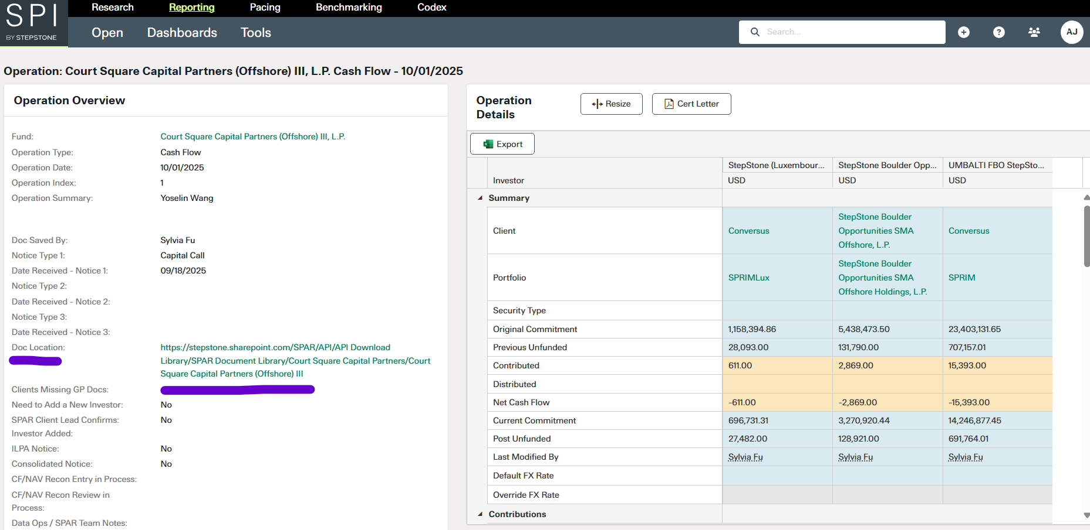
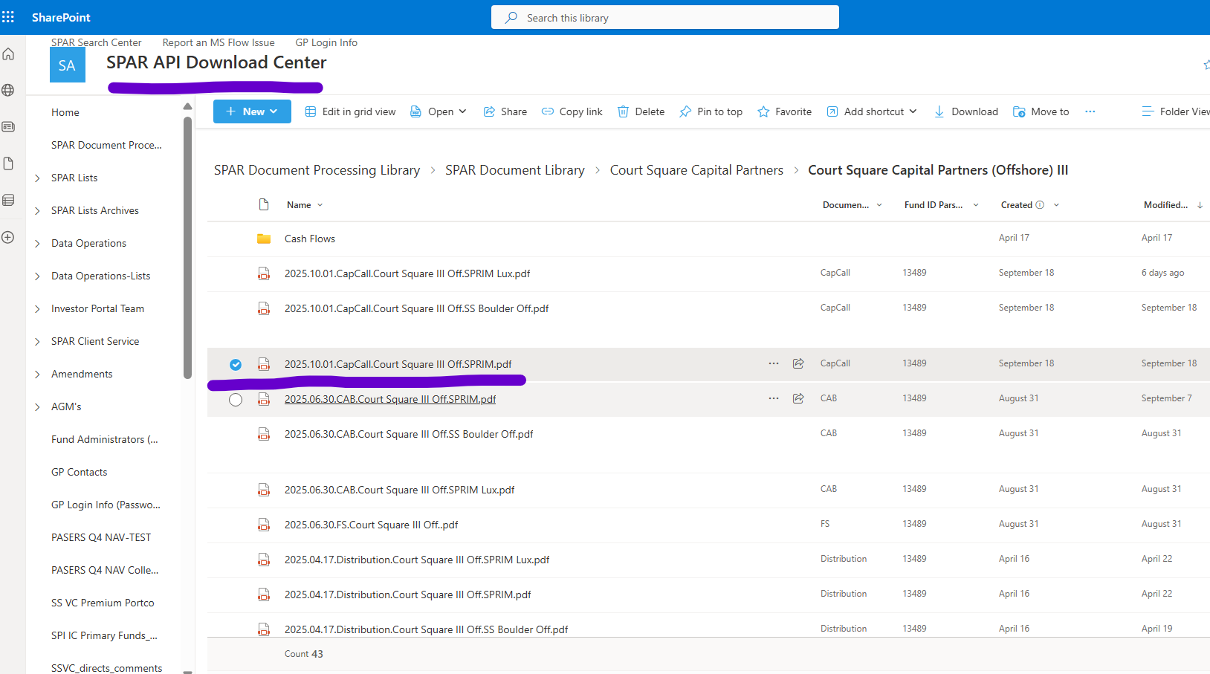

Automation Platform Options

Option 1 – SharePoint-Based Microsoft 365 Platform
This option provides a lower-cost minimum viable platform using standard Microsoft 365 components wherever possible. SharePoint acts as the workflow database and document repository, Power Apps provides the user interface, Power Automate manages workflow and approvals, and Excel remains the controlled weekly output.

Core Components
- SharePoint document libraries: Store capital-call notices, supporting evidence, weekly output files, and archived approval packages.
- SharePoint lists: Maintain capital-call records, approved wire instructions, exceptions, approval history, and configuration data.
- Power Apps canvas app: Provide intake, review, approval-status, search, and exception-management screens.
- Power Automate: Monitor folders and email, create workflow records, validate data, generate weekly files, request approvals, send reminders, and archive evidence.
- Excel: Produce a fresh dated weekly wire file from a locked master template.
- Teams or Outlook: Deliver alerts, approval requests, reminders, and completion notifications.

Suggested SharePoint Lists
- Capital Calls: Transaction ID, fund, investment, due date, amount, currency, account name, notice link, evidence link, status, maker, checker, and comments.
- Wire Instruction Master: Investment ID, beneficiary, bank, masked account identifier, routing/SWIFT details, currency, effective date, verification date, approver, and active status.
- Exceptions: Transaction ID, exception type, severity, owner, due date, resolution, and closure date.
- Workflow Configuration: weekly cutoff, approval thresholds, confidence threshold, supported currencies, escalation timing, and notification recipients.

Primary Flows
- Capture a notice from SharePoint or a monitored mailbox and create a transaction record.
- Route the record for manual data entry or approved document extraction.
- Validate required fields, duplicates, due-date window, supported currency, and wire-master matching.
- Create an exception when a field is missing, a duplicate is detected, or banking details have changed.
- Populate a new weekly Excel file from the master template.
- Obtain sequential maker and checker approvals.
- Notify the payment team when a record is approved and ready.
- Archive the notice, evidence, approvals, output, and reconciliation result.

Advantages and Constraints
Advantages: Faster implementation, lower licensing dependency, familiar tools, simple administration, and a suitable path for an initial pilot.
Constraints: SharePoint lists are less relational than Dataverse, field-level security is limited, complex audit and integration requirements require more custom design, and high transaction volumes may reduce maintainability.

Option 2 – Dataverse and AI Builder Enterprise Platform
This option provides a scalable production platform with stronger relational data, security, auditability, document extraction, integration, and application lifecycle management. Dataverse is the system of record, SharePoint stores documents, Power Apps manages user activity, AI Builder extracts notice data, and Power Automate orchestrates the end-to-end process.

Core Components
- Dataverse: Store capital calls, investments, approved wire instructions, extraction results, approvals, exceptions, and audit records.
- SharePoint: Store source notices, supporting pages, generated weekly files, and retained evidence packages.
- Power Apps: Provide role-based work queues, transaction review, exception resolution, wire-master administration, and approval history.
- AI Builder: Extract fund, investment, due date, amount, currency, account name, beneficiary, bank, account identifier, and routing/SWIFT information from notices.
- Power Automate: Handle ingestion, extraction, validations, approvals, escalations, weekly output, downstream integration, and closure.
- Power BI: Report upcoming payments, approval aging, exception volumes, processing time, and failed validations.

Suggested Dataverse Tables
- Funds: Fund ID, name, legal entity, base currency, active status, and responsible team.
- Investments: Investment ID, fund relationship, SPI/SPAR identifier, name, aliases, and active status.
- Capital Calls: Transaction ID, notice metadata, due date, amount, currency, source, status, maker, checker, and reconciliation result.
- Wire Instructions: Effective-dated beneficiary and bank details, verification method, verification date, approver, version, and status.
- Extraction Results: Extracted values, confidence by field, source-page reference, reviewer correction, and model version.
- Approvals: Stage, approver, decision, decision time, comments, and data version approved.
- Exceptions: Type, severity, owner, service-level deadline, resolution, and closure evidence.
- Audit Events: User or process action, timestamp, prior value, new value, and transaction relationship.

Automated Processing Rules
- Ingest the notice and create a unique capital-call transaction.
- Run document extraction and save every field with its confidence score and source-page reference.
- Send low-confidence or conflicting values to a reviewer work queue.
- Match the investment using a stable identifier and controlled aliases rather than name alone.
- Compare notice instructions with the effective approved wire-instruction version.
- Block any new, expired, ambiguous, or changed banking instruction and require independent verification.
- Perform duplicate, amount, currency, due-date, and mandatory-field controls.
- Generate the weekly output only from records that passed validation.
- Apply maker-checker approval against a fixed data version; any material change returns the record to draft.
- Integrate with SPI/SPAR or downstream payment systems only through an approved API, report, or secure file interface.
- Reconcile the executed payment and close the transaction only when notice, approval, and payment values agree.

Advantages and Constraints
Advantages: Strong relational controls, role-based security, detailed audit history, scalable exception handling, robust integration, reusable master data, and better support for production operations.
Constraints: Premium licensing, AI Builder capacity, environment administration, model training, security review, and a longer implementation and testing period are required.
- Comparison of Platform Options
- Area | - SharePoint-Based Option | - Dataverse and AI Builder Option
- Best use | - Pilot or lower-volume operational process | - Enterprise production platform
- System of record | - SharePoint Lists | - Dataverse
- Document storage | - SharePoint | - SharePoint
- Notice extraction | - Manual entry or optional approved extraction | - AI Builder with confidence-based review
- Data relationships | - Basic lookup-based design | - Strong relational design
- Security | - Site, list, library, and item permissions | - Role, table, row, and environment controls
- Auditability | - Version history plus custom workflow logs | - Structured audit events and data-version approvals
- Integration | - Suitable for standard connectors and exports | - Better for APIs, secure interfaces, and complex orchestration
- Scalability | - Moderate | - High
- Implementation effort | - Lower | - Higher
- Licensing impact | - Lower; depends on connectors and extraction choices | - Higher; premium Power Apps, Dataverse, and AI Builder capacity may apply
- Recommended decision | - Use for rapid proof of concept and control validation | - Use for the long-term controlled production solution

Common Controls Required for Both Options
- Final payment release remains outside the automation unless separately authorized under treasury controls.
- New or changed banking instructions are blocked and independently verified.
- Maker and checker must be different authorized users.
- Material changes after approval return the transaction to draft and restart approval.
- Access to full bank details is restricted and reviewed periodically.
- Every transaction retains the original notice, evidence, validation result, approvals, output, and reconciliation record.
- Duplicate detection uses fund, stable investment identifier, amount, currency, due date, and notice reference.
- A documented fallback procedure applies when extraction, integration, or workflow services are unavailable.

Recommended Delivery Approach
Build the SharePoint-based option first as a controlled proof of concept. Use it to validate field definitions, exception categories, maker-checker roles, weekly deadlines, and the output template. Design the lists and identifiers so that they can later be migrated to Dataverse without changing the business process.
- Weeks 1–2 – Design: Confirm requirements, controls, user roles, data fields, source locations, weekly cutoff, and exception ownership.
- Weeks 3–4 – MVP build: Configure SharePoint libraries and lists, create the Power App, automate intake and reminders, and generate the weekly workbook.
- Weeks 5–6 – Controls: Add duplicate checks, wire-master comparison, maker-checker approval, exception handling, and audit evidence.
- Weeks 7–8 – Pilot: Run the platform and the manual process in parallel, compare every transaction, remediate defects, and obtain control-owner sign-off.
- Enterprise migration: If volumes, security requirements, document variation, or integration complexity justify it, migrate the validated design to Dataverse and enable AI Builder extraction.

Decision Criteria
Select the SharePoint-based option when rapid delivery and lower licensing dependency are the main priorities and volumes are manageable. Select the Dataverse and AI Builder option when the process requires stronger security, structured auditability, complex data relationships, automated document extraction, downstream integration, and long-term scale.
Recommended target: Use the SharePoint option for the pilot and the Dataverse option as the strategic production architecture, subject to licensing, Information Security, Treasury, Risk, and process-owner approval.

Conclusion
In summary, this project ensures accurate and consistent capital calls for US funds by preparing a weekly template with wire instructions. By updating and verifying details from capital call notices and sourcing bank account information, we support timely payments and enhance financial management and operational efficiency

